Due to a uboot bug, flashing openwrt firmware without flashing transition image will cause s1300 brick.

Flashing openwrt should following the this guide.

<https://github.com/gl-inet/openwrt/blob/openwrt-18.06-s1300/README.md>

Once s1300 bricked, reprogramming the NOR flash is needed. You need a CH341a SPI sop8 programmer, like the following link.

<https://www.youtube.com/watch?v=2Y06x1f22B0>

Steps to fix:

1. send us label of the device, we need MAC address to get your device’s 16M NOR image.

2. reprogram the 16M NOR image we send.

Steps to reprogram NOR flash:

1. open the device: remove the four rubber foot, and turn off the screw, remove the antenna and heat sink, the NOR flash is on the right top part of the board like the picture.

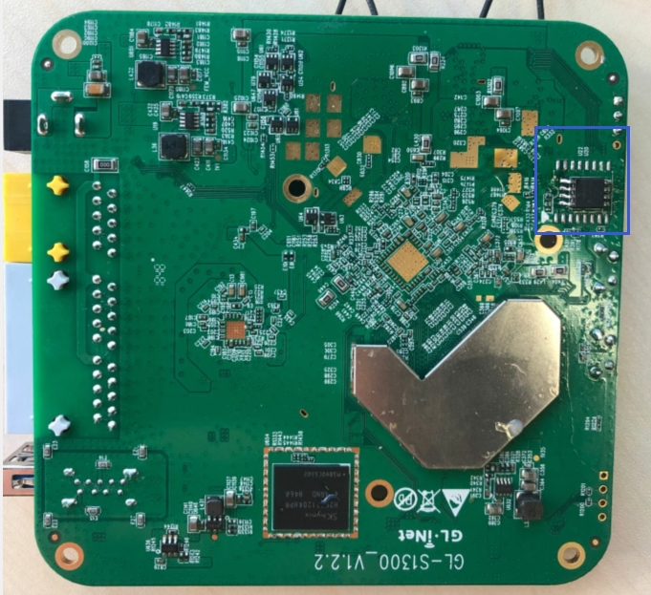

2. connecting programmer and NOR flash:

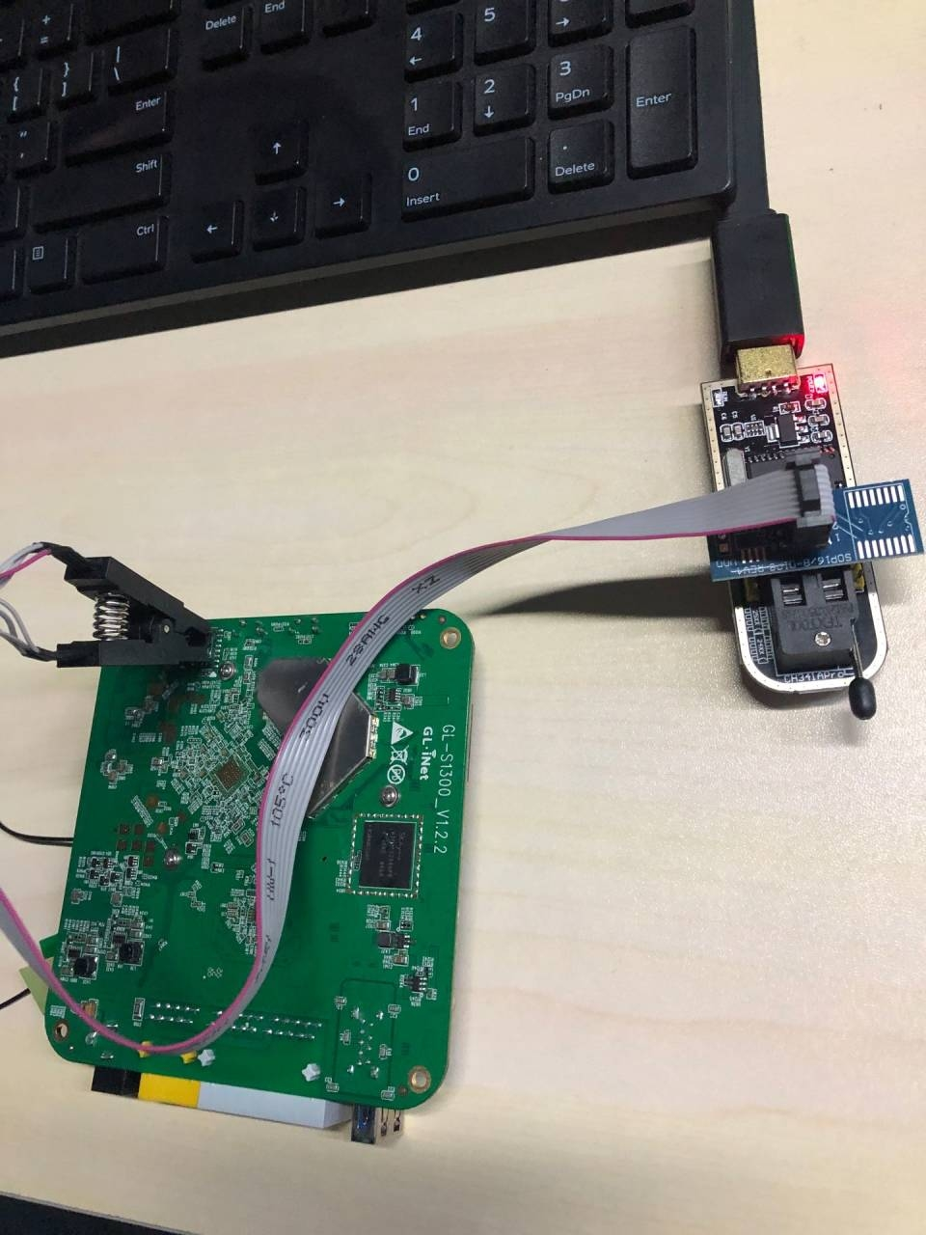

3.

Using the 16M image we send to program the NOR flash, by windows software(like following picture), or linux command:

flashrom --programmer ch341a_spi -w ~/Downloads/s1300_nor_image/16M.bin

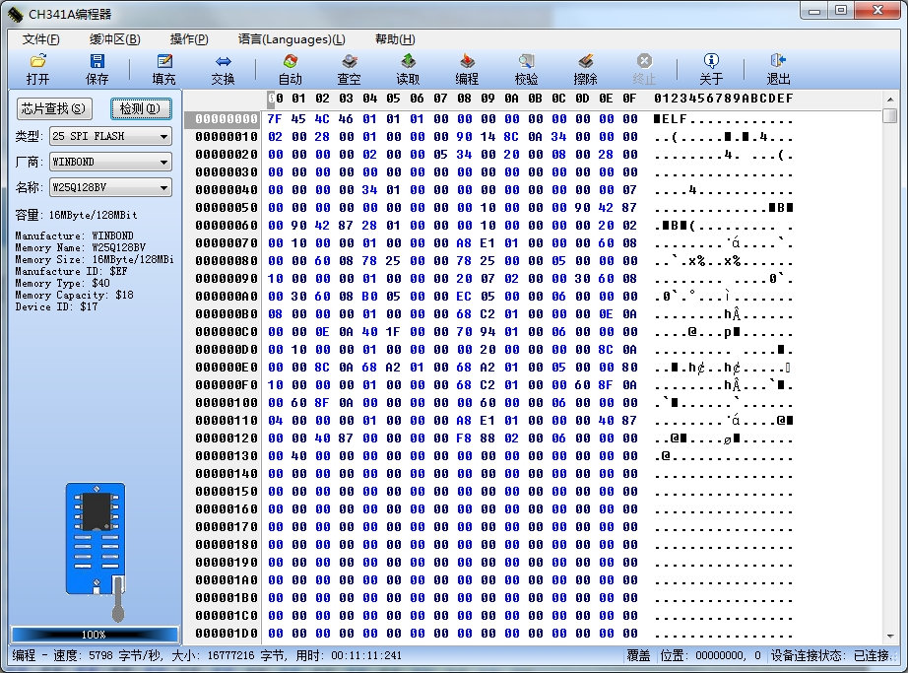

This step varies with the programmer you use.